Kenya

## Population Data

The data set shows the political stability estimate of the country each year.

## # A tibble: 23 x 5  
## country iso3c date population popCategory5  
## <chr> <chr> <dbl> <dbl> <chr>   
## 1 Kenya KEN 1996 28589451 medium   
## 2 Kenya KEN 1997 29415659 medium   
## 3 Kenya KEN 1998 30250488 medium   
## 4 Kenya KEN 1999 31098757 medium   
## 5 Kenya KEN 2000 31964557 medium   
## 6 Kenya KEN 2001 32848564 medium   
## 7 Kenya KEN 2002 33751739 medium   
## 8 Kenya KEN 2003 34678779 medium   
## 9 Kenya KEN 2004 35635271 medium   
## 10 Kenya KEN 2005 36624895 medium   
## 11 Kenya KEN 2006 37649033 medium   
## 12 Kenya KEN 2007 38705932 medium   
## 13 Kenya KEN 2008 39791981 medium   
## 14 Kenya KEN 2009 40901792 medium   
## 15 Kenya KEN 2010 42030676 medium   
## 16 Kenya KEN 2011 43178257 medium   
## 17 Kenya KEN 2012 44343410 medium   
## 18 Kenya KEN 2013 45519889 medium   
## 19 Kenya KEN 2014 46699981 medium   
## 20 Kenya KEN 2015 47878336 medium   
## 21 Kenya KEN 2016 49051686 medium   
## 22 Kenya KEN 2017 50221473 medium   
## 23 Kenya KEN 2018 51393010 medium

# Population growth data

## # A tibble: 23 x 5  
## country iso3c date popGrowth popGrowthCat5   
## <chr> <chr> <dbl> <dbl> <chr>   
## 1 Kenya KEN 1996 2.91 high growth rate   
## 2 Kenya KEN 1997 2.85 high growth rate   
## 3 Kenya KEN 1998 2.80 high growth rate   
## 4 Kenya KEN 1999 2.77 high growth rate   
## 5 Kenya KEN 2000 2.75 high growth rate   
## 6 Kenya KEN 2001 2.73 high growth rate   
## 7 Kenya KEN 2002 2.71 high growth rate   
## 8 Kenya KEN 2003 2.71 high growth rate   
## 9 Kenya KEN 2004 2.72 high growth rate   
## 10 Kenya KEN 2005 2.74 high growth rate   
## 11 Kenya KEN 2006 2.76 high growth rate   
## 12 Kenya KEN 2007 2.77 high growth rate   
## 13 Kenya KEN 2008 2.77 high growth rate   
## 14 Kenya KEN 2009 2.75 high growth rate   
## 15 Kenya KEN 2010 2.72 high growth rate   
## 16 Kenya KEN 2011 2.69 high growth rate   
## 17 Kenya KEN 2012 2.66 high growth rate   
## 18 Kenya KEN 2013 2.62 high growth rate   
## 19 Kenya KEN 2014 2.56 high growth rate   
## 20 Kenya KEN 2015 2.49 moderate growth rate  
## 21 Kenya KEN 2016 2.42 moderate growth rate  
## 22 Kenya KEN 2017 2.36 moderate growth rate  
## 23 Kenya KEN 2018 2.31 moderate growth rate

## Population trend

The plot shows the population trend of the country.

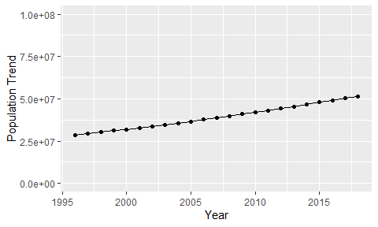

Political Stability Trend

# Population growth trend

The plot shows the population growth rate trend of the country.

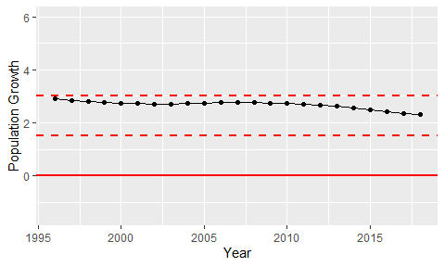

Population Growth Trend